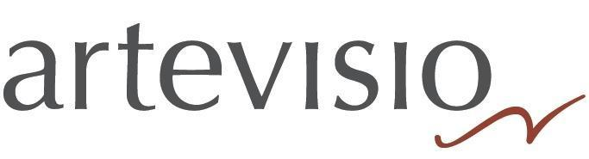

PAVEL HAAS QUARTET (EN)
The Pavel Haas Quartet is firmly established as one of the world’s foremost chamber ensembles. The Quartet is revered across the globe for its richness of timbre, infectious passion and intuitive rapport. Performing at the world’s most prestigious concert halls and having won five and numerous others for their recordings. In 2022, the prestigious BBC Music Magazine ranked them among the 10 greatest string quartets ensembles of all time.
The Quartet appears at major venues including Wigmore Hall, London; Philharmonie and Konzerthaus, Berlin; Musikverein, Vienna; Elbphilharmonie, Hamburg; Concertgebouw and Muziekgebouw, Amsterdam; Tonhalle, Zürich; Théâtre de la Ville, Paris; Accademia di Santa Cecilia, Rome; BOZAR, Brussels; NCPA, Beijing; LG Arts Centre, Seoul and Carnegie Hall, New York.
In the 2023/2024 season, the Quartet returns to the Wigmore Hall for four concerts; Rudolfinum Prague; Reduta Bratislava; Teatro La Fenice; Liverpool Philharmonic Hall; Göteborgs Konserthus; National Concert Hall, Dublin; Muziekgebouw, Amsterdam; Philharmonie Luxembourg. Further afield, the Quartet tours the United States in March 2024 and Asia in May 2024. The ensemble will also perform at leading Czech festivals, including Dvořák's Prague or Prague Spring. Since September 2022, the Pavel Haas Quartet has been Artist-in-Residence at the Dvořák Prague Festival and curate the chamber music concerts including programming all the Dvořák String Quartets and chamber music works over the three seasons.
The Pavel Haas Quartet records exclusively for Supraphon. Their most recent recording of the Brahms Viola and Piano Quintets with Boris Giltburg and their former member, Pavel Nikl, was released to critical acclaim in May 2022. The recording was described as “radiant and vivacious” by The Strad, and was Presto Classical’s Recording of the Week. For their previous album of Shostakovich String Quartets (2019), they received the Recording of the Year by Classic Prague Awards and were named one of the 100 best records of the year by The Times.
The Quartet received their five Gramophone Awards for their recordings of Dvořák, Smetana, Schubert, Janáček and Haas, as well as Dvořák’s String Quartets No.12 ‘American’ and No.13, for which they were awarded the most coveted prize, Gramophone Recording of the Year in 2011. The Sunday Times commented: “their account of the ‘American’ Quartet belongs alongside the greatest performances on disc.” Further accolades include BBC Music Magazine Awards and the Diapason d’Or de l’Année in 2010 for their recording of Prokofiev String Quartets Nos. 1 & 2.
Since winning the Paolo Borciani competition in Italy in 2005, further highlights early on in their career have included the nomination as ECHO Rising Stars in 2007, the participation in the BBC New Generation Artists scheme between 2007-2009 and the Special Ensemble Scholarship the Borletti-Buitoni Trust awarded to them in 2010.
The Pavel Haas Quartet was founded in 2002 by the violinist Veronika Jarůšková and the violist Pavel Nikl, who was a member of the ensemble until 2016, when he left due to family reasons. Yet their collaboration has continued – Pavel Nikl has been the ensemble’s permanent guest for string quintet performances. The member of quartet studied with the late Milan Skampa, the legendary violist of the Smetana Quartet. The ensemble take their name from the Czech-Jewish composer Pavel Haas (1899-1944) who was imprisoned at Theresienstadt in 1941 and tragically died at Auschwitz three years later. His legacy includes three wonderful string quartets.

